Index

|  |  |  |
| --- | --- | --- |
| **Sr.**  **No.** | **Contents** | **Page No.** |
| **1** | **Annexure I– Micro Project Proposal** | **1-2** |
| 1.Aims/Benefits of the Micro-Project | 1 |
| 2. Course Outcome Addressed | 1 |
| 3.Proposed Methodology | 1 |
| 4. Action Plan | 2 |
| 5. Resources Required | 2 |
| 6. Name of Team Members with Roll No.’s | 2 |
| **2** | **Annexure II – Micro Project Report** | **3-8** |
| 1.Rationale | 3 |
| 2.Aims/Benefits of the Micro-Project | 3 |
| 3.Course Outcome Achieved | 3 |
| 4. Literature Review | 4 |
| 5.Actual Methodology Followed | 5 |
| 5.1 Flow chart | 5 |
| 5.2 Source code | 6-8 |
| 6.Actual Resources Used | 9 |
| 7.Outputs of Micro-Projects | 9 |
| 8. Skill developed / Learning out of this Micro-Project | 13 |
| 9. Applications of this Micro-Project | 13 |

## Annexure I

**Micro Project Proposal**

# “Design a Rotating Fan”

## Aims/Benefits of the Micro-Project:

* 1. Understanding the computer graphics and its applications like rotating fan.
  2. To find working mechanism of graphics by using computer graphics.
  3. To understand the graphics, functions and execution of the ‘C’ program.

## Course Outcome Addressed:

1. CO1-Manipulate visual and geometric information of images.
2. CO2-Implement standard algorithms to draw various graphics objects using C program.
3. CO3-Develop programs for 2-D and 3-D Transformations.
4. CO4-Use projections to visualize objects on view plane.
5. CO5-Implement various clipping algorithms.
6. CO6-Develop programs to create curves using algorithms.

## Proposed Methodology:

Here we are using computer graphics to rotating fan.

We have added functions ouottextxy();, rectangel();, delay(); And many more.

Compiler will perform chosen arithmatic operations in given program and give output to us as rotating fan graphics.

## Action Plan:

|  |  |  |  |  |
| --- | --- | --- | --- | --- |
| **Sr.**  **No.** | **Details of Activity** | **Planned**  **Start date** | **Planned**  **Finish date** | **Name of Responsible**  **Team Members** |
| 1 | Search the topic | 06/04/2021  4:00pm-5:00pm | 13/04/2021  4:00pm-5:00pm | Amay Nitin  Devshtwar |
| 2 | Search the information | 20/04/2021  4:00pm-5:00pm | 27/04/2021  4:00pm-5:00pm | Somesh Mahadev  Bharbade |
| 3 | Algorithm developing | 04/05/2021  4:00pm-5:00pm | 08/05/2021  4:00pm-5:00pm | Omanand Prashant  Swami |
| 4 | Flowchart developing | 11/05/2021  4:00pm-5:00pm | 15/05/2021  4:00pm-5:00pm | Omanand Prashant  Swami |
| 5 | Function making | 18/05/2021  4:00pm-5:00pm | 22/05/2021  4:00pm-5:00pm | Amay Nitin  Devshtwar |
| 6 | Coding developing | 25/05/2021  4:00pm-5:00pm | 29/05/2021  4:00pm-5:00pm | Omanand Prashant  Swami |
| 7 | Debugging | 01/06/2021  4:00pm-5:00pm | 05/06/2021  4:00pm-5:00pm | Amay Nitin  Devshtwar |
| 8 | Finalizing Project with its  report | 07/06/2021  4:00pm-5:00pm | 09/06/2021  4:00pm-5:00pm | Somesh Mahadev  Bharbade |

1. **Resources Required:**

|  |  |  |  |  |
| --- | --- | --- | --- | --- |
| **Sr.**  **No.** | **Name of resource / material** | **Specification** | **Quantity** | **Remarks** |
| 1 | Computer | WINDOWS 11,8 GB  RAM, 256GB SSD | 1 |  |
| 2 | Operating System | WINDOWS 11 | 1 |  |
| 3 | Compiler | Turbo C/GCC/VS Code | 1 |  |
| 4 | Browser | Chrome | 1 |  |

## Names of Team Members with Roll No.’s:

|  |  |  |  |
| --- | --- | --- | --- |
| **Sr.**  **No.** | **Enrollment No.** | **Name of Team Member** | **Roll No.** |
| 1 | 21109500050 | Omanand Prashant Swami | 02 |
| 2 | 21109500103 | Somesh Mahadev Bharbade | 54 |
| 3 | 21109500088 | Amay Nitin Devshatwar | 39 |
|  |  |  |  |
|  |  |  |  |

**Mr. Kazi A.S.M.**

## Name and Signature of the Teacher

* **Rationale:**

**Micro-Project Report**

# “Design a Rotating Fan”

**Annexure – II**

Creating a simple rotating fan to present computer graphics and its application in various sector like animation, game etc... using VS Code.

## Aims/Benefits of the Micro-Project:

* 1. Understanding the computer graphics and its applications like rotating fan.
  2. To find working mechanism of graphics by using computer graphics.
  3. To understand the graphics, functions and execution of the ‘C’ program.

## Course Outcome Addressed:

1. CO1-Manipulate visual and geometric information of images.
2. CO2-Implement standard algorithms to draw various graphics objects using C program.
3. CO3-Develop programs for 2-D and 3-D Transformations.
4. CO4-Use projections to visualize objects on view plane.
5. CO5-Implement various clipping algorithms.
6. CO6-Develop programs to create curves using algorithms.

## Literature Review:

Here we are using computer graphics to create rotating fan.

We have added functions ouottextxy();, rectangel();, delay(); And many more.

Compiler will perform chosen arithmatic operations in given program and give output to us as rotating fan graphics.

* Initgraph()-

This Initgraph function in one of most important function from graphics.h library in ‘C’ Language.

* With this function we initialize ( start ) graphics in our computer system.
* After this function we will write our remaining graphics program.

**Syntax:**

);

PATH

,

gmode

&

,

gdriver

&

initgraph

(

➔ **Important Points about Initgraph function :**

* + The expression provided in the path argument must path to BGI file from Turbo C.

**Valid expressions for initgraph function:**

void main(void)

{

int gdriver = DETECT, gmode;

// Path =>>> "C:/TURBOC3/BGI"

initgraph(&gdriver, &gmode, "C:/TURBOC3/BGI"); closegraph();

}

## Graphics must be get closed with closegraph() funciton.

* + To design rotating fan we have to use for loop to iterate.
  + To print some text on output screen we will use outtextxy() function.
  + As a base of that rotating fan we have to use rectangle() function.
  + We will use if control statement to check some conditions in our program.
  + After all we will perform some more arithmatical operations and will display the output as a rotating fan.
  + Lastly we will close the graphics with closegraph() function.

## Actual MethodologyFollowed:

* 1. **Flow Chart**

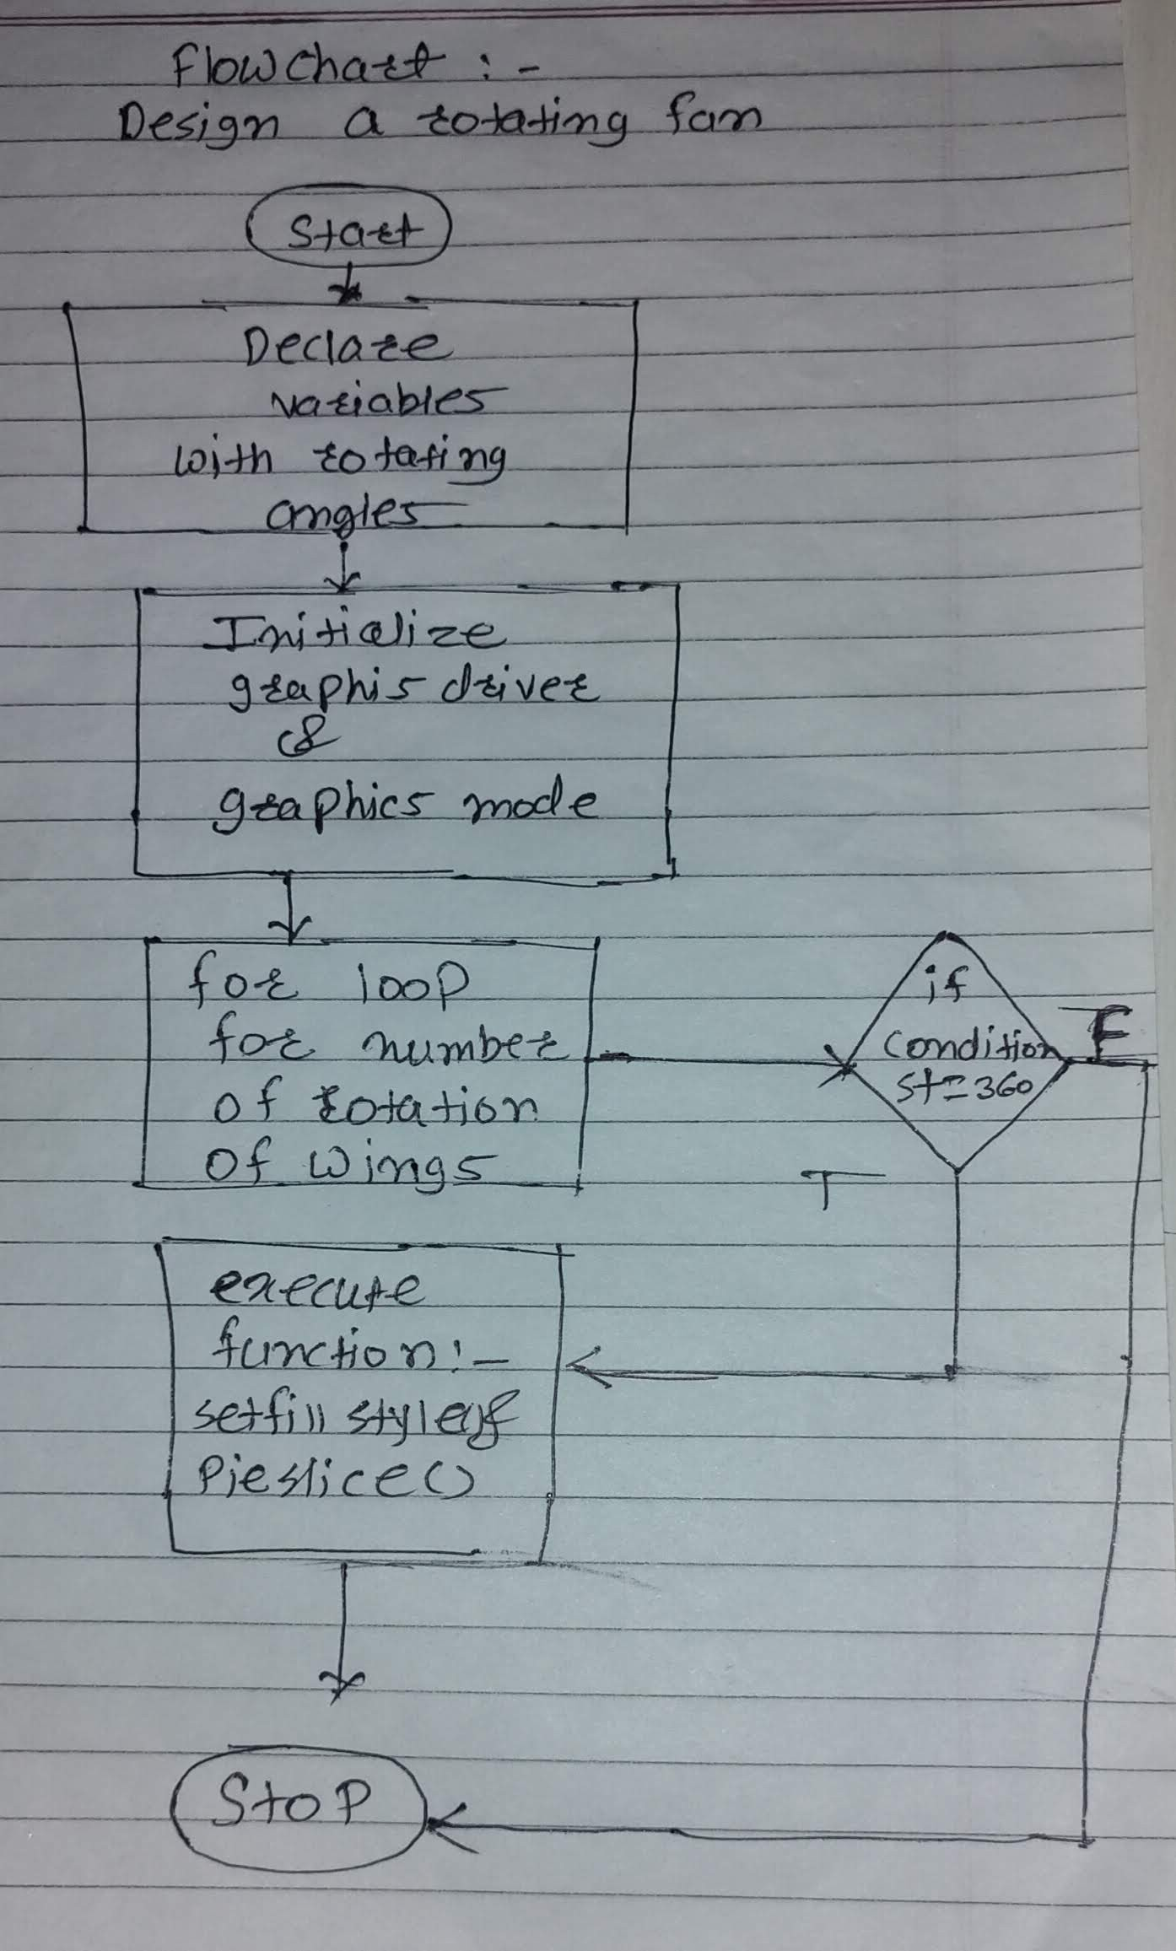

* 1. **Source Code**

# “Design a Rotating Fan”

#include <graphics.h> #include <stdlib.h> #include <stdio.h> #include <conio.h> #include <dos.h>

int main(void)

{

/* request auto detection */ int gdriver = DETECT, gmode;

// int errorcode; int i, midx, midy;

int stangle1 = -45, endangle1 = 0, radius = 100; int stangle2 = 135, endangle2 = 180;

/* initialize graphics and local variables */

// Graphics initialization For Turbo CPP With BGI Path. initgraph(&gdriver, &gmode, "C:/TURBOC3/BGI");

// Graphics initialization For VS Code With Null argument.

// initgraph(&gdriver, &gmode, NULL);

/* mid position of x in x-axis */ midx = getmaxx() / 2;

/* mid position of y in y-axis */ midy = getmaxy() / 2;

for (i = 0; i < 400; i++)

{

/* start and end angle of fan's first wing */ if (endangle1 == 360)

{

stangle1 = -45;

endangle1 = 0;

}

if (endangle2 == 360)

{

stangle2 = -45;

endangle2 = 0;

}

/* clears graphic device */ cleardevice();

// Our Names And Enrollment Numbers.

outtextxy(150, 8, "Computer Graphics Micro-Project By CO3I Students Of VAPM =>>>");

outtextxy(230, 30, "Subject:=>>> Design a Rotating Fan"); outtextxy(200, 53, "i] 2110950050 Omanand Prashant Swami"); outtextxy(200, 76, "ii] 2110950088 Amay Nitin Devshatwar"); outtextxy(200, 100, "iii] 2110950103 Somesh Mahadev Bharbade");

// Arithmatic calculation for generating angles. stangle1 = stangle1 + 45;

stangle2 = stangle2 + 45; endangle1 = endangle1 + 45; endangle2 = endangle2 + 45;

/* fan stand */

rectangle(midx - 5, midy - 5, midx + 5, midy + 150);

/* draws first wing of fan */ setfillstyle(SLASH_FILL, i % 10);

pieslice(midx, midy, stangle1, endangle1, radius);

/* draws second wing of fan */ setfillstyle(BKSLASH_FILL, i % 10);

pieslice(midx, midy, stangle2, endangle2, radius);

/* sleep for 40 millisecond */ delay(100);

}

/* clean up */ getch();

/* deallocate memory allocated for graphic screen */

// closegraph(); return 0; }

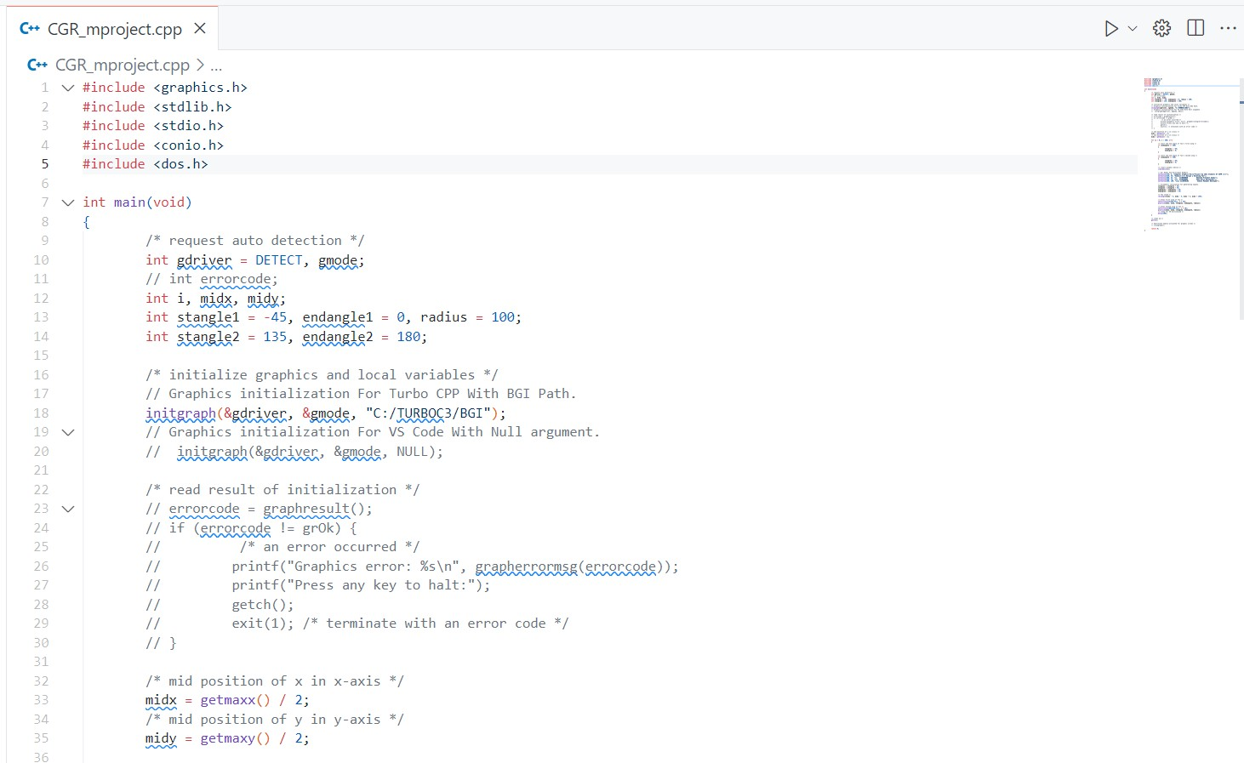

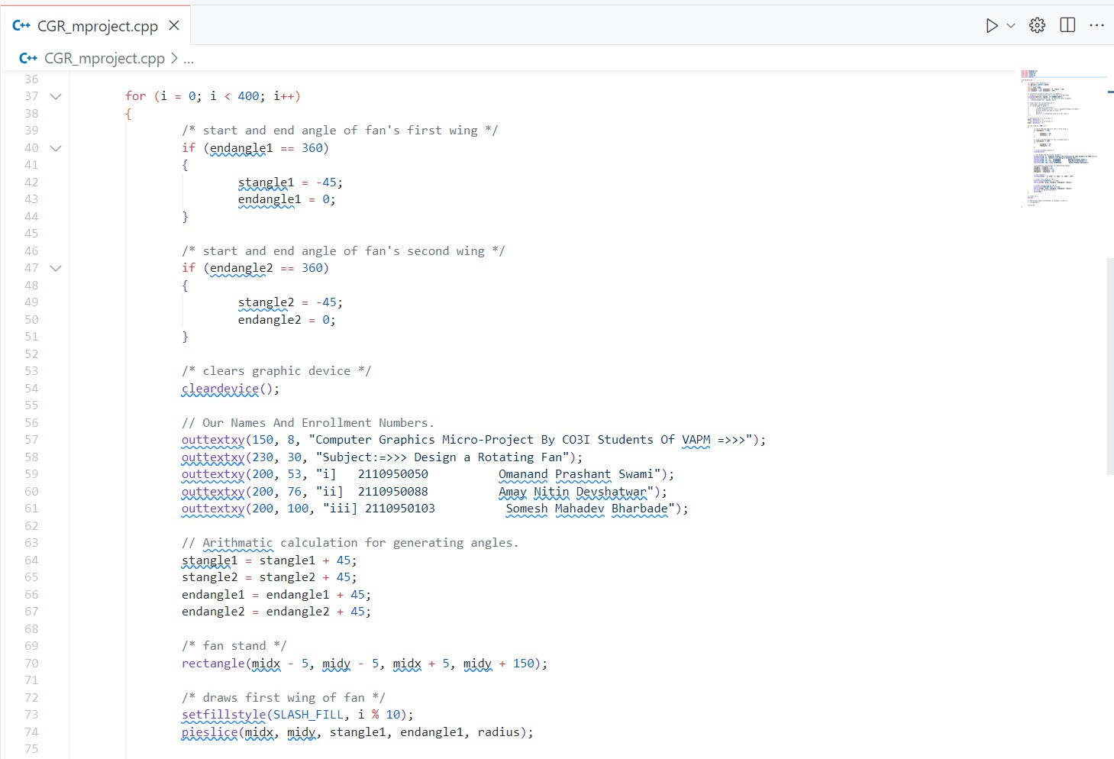

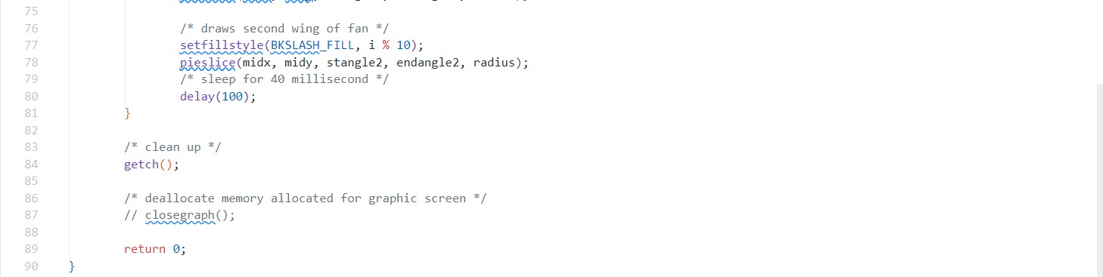

## Actual Resources Used:

|  |  |  |  |  |
| --- | --- | --- | --- | --- |
| **Sr.**  **No.** | **Name of resource / material** | **Specification** | **Quantity** | **Remarks** |
| 1 | Computer | WINDOWS 11,8GB  RAM, 256GB SSD | 1 |  |
| 2 | Operating System | WINDOWS 11 | 1 |  |
| 3 | Compiler | Turbo C/GCC/VS code | 1 |  |
| 4 | Browser | Chrome | 1 |  |

1. **Outputs of Micro-Projects:**

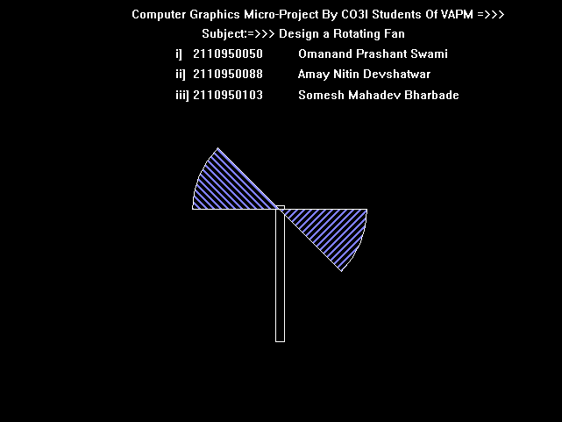

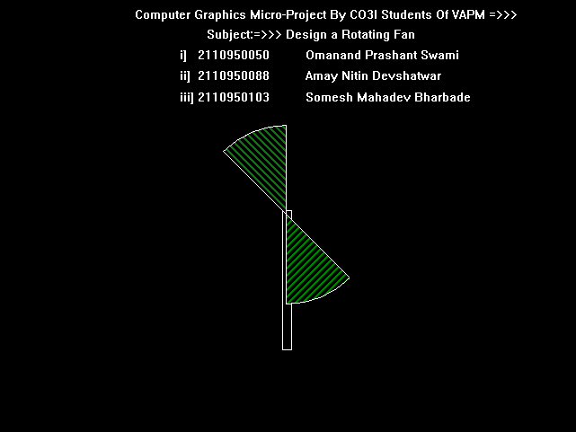

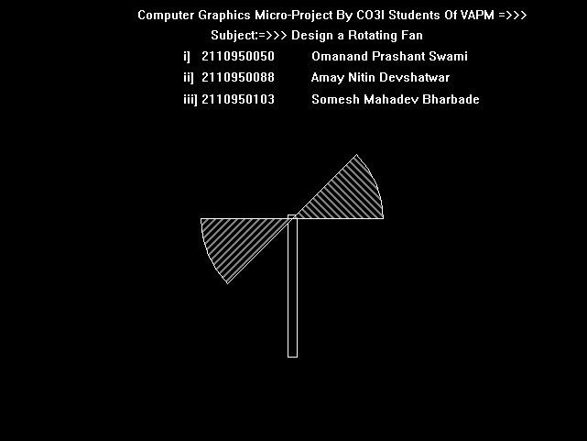

## Skill developed / Learning out of this Micro-Project:

There are so many thing that we learn from this project :==>>>

* 1. We learn that how to make the project in c programming.
  2. How to design computer graphics in ‘C’ Language.
  3. How to collect the information and how to make the presentation that we learn from this project.
  4. We develop our logic implementation for programming and coding as well as for designing graphics.
  5. We learn to use vary functions of graphics.
  6. We learn how to create different designs and shapes with different graphical function.
  7. We learn some keywords and funtions from ‘dos.h’ & ‘stdlib.h’ header file.
  8. We learnt lot more things like logic building and enhancement from this project.

## Applications of this Micro-Project:

* + 1. also be used to design graphics with implimenting this project on large scale.It can be used to understand computer graphics.
    2. It can
    3. It can also be used to make animations UI development , Game development Etc…..

*********